**STUDY OF THE THERMAL PROCESSES DYNAMICS IN THE FEEDSTUFF DISINFECTION BY ELECTRIC CONTACT HEATING**

**T.M. Khalina1, M.V. Khalin1, M.V. Dorozhkin1**

1 Polzunov Altai State Technical University (ASTU), 656038, pr. Lenina, 46, Barnaul, Russia

E-mail: temf@yandex.ru

**Abstract.** The article is dedicated to the study of the heat transfer processes that occur in the feedstuff disinfection chamber that relies upon electric contact heating. The mechanism of the temperature gradient appearance, which is the main cause of the heat losses has been investigated. The basic equations of heat conduction are considered. A method is proposed for determining the key parameters of the heat transfer process. A functional diagram of the experimental setup with a description of the operation of individual units is presented. The dependence for the transient operating mode of the unit on the growth of heat losses has been established. Thermal images of different shapes of the unit dielectric chambers have been provided as well as temperature field distribution through the chamber wall.

**Keywords:** electric contact heating, feedstuff disinfection, heat losses, heat transmission coefficient, heat exchange.

On the current markets, environmentally friendly and less resource-intensive technologies are usually more preferable. As a rule, the efficiency of such systems is associated with thermal processes, and primarily heat loss. The study of the mechanism of heat losses, in particular, the analysis of the factors that have the greatest influence on their level, is one of the main tasks as regards the increase in energy efficiency [1]. The above is more true for the processes that provide changes in the thermophysical characteristics of the feedstuff, for example, the technology of electric contact (EC) disinfection of wet feed mixtures used in animal husbandry [2].

The EC disinfection belongs to the thermal feedstuff processing methods. The feedstuff disinfection effect is achieved through the exposure of pathogenic organisms to the temperature (60…80 ˚С) that is fatal for their life [3, 4]. The EC technology is based upon the volumetric heating of the feed mixture by the heat generated as a result of the current being passed through the feedstuff disinfected [2]. According to Joule-Lenz's law, the amount of heat generated in an elementary volume can be described by the following equation [5, 6]:

 (1)

where *I* – RMS current, А; *R* – resistance of a conductive medium, Ohm.

Heat generation in the feed mixture leads to an increase in its internal temperature. As a result of the fact that the container in which the heating occurs has contact with a colder carrier, a temperature gradient arises at the boundary of the feed mixture - the chamber wall - air, due to which part of the heat is spent through heat exchange processes for parasitic heating of the environment. The greater the temperature gradient between hot and cold objects the higher the heat loss, provided that the remaining parameters of the system are constant [7].

The main task in determining the amount of heat transferred through an arbitrary surface is to find the characteristic points of the temperature field inside the object under consideration [1, 7-10]. As a rule these points are the temperatures of the hot (feed mixture) and cold (air) coolants, as well as the temperatures of the inner and outer walls of the partition dividing them.

An EC unit operating process may be divided into two stages:

- continuous heating of the feed mixture with the achievement of the temperature required (transient mode);

- keeping the feed mixture under a constant temperature during time established under the process (steady state).

Each of the modes suggests its own approach to the establishing thermal parameters dynamics.

**Procedure for Determination of Heat Losses**

For the steady-state mode and the boundary conditions of the third kind (Figure 1) the amount of heat transmitted by the heated mixture to the wall by means of heat exchange is determined based on the Newton-Richmann equation [1]:

 (2)

where *α*1 – coefficient of heat transmission by the hot medium with a temperature of *t*m to the wall surface, W/(m2⋅˚С); *F* – flat wall surface area, m2; ******– surface temperature of the wall bordering with the hot heat transfer agent, ˚С.

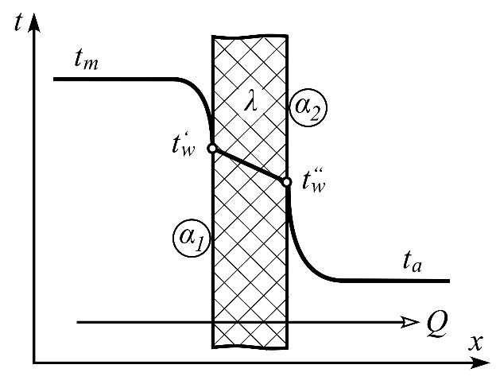

***Figure 1 – Diagram of Temperature Change through a Flat Wall***

Depending on the heat exchange conditions, calculation of the heat transmission coefficient *α*1 can include all its types, however, as applied to the EC heating technology, there is no temperature gradient as a result of almost uniform internal heating throughout the entire volume of the feed mixture [2, 5]. Due to the insignificant movement of the liquid in the mixture under such conditions, heat exchange is by convection replaced by thermal conductivity.

Heat is transferred through a flat wall by thermal conductivity and can be described by the following equation [1]:

 (3)

where *λ* – wall material heat transmission coefficient, W/(m⋅˚С); *δ* – wall thickness, m; ******– temperature of the internal and external wall surfaces, ˚С.

Air stream from the outer wall surface to the cold air with a temperature of *ta* is calculated similarly to the calculation of heat for the hot mixture - internal container wall surface region [1]:

 (4)

where *α*2 – coefficient of heat transmission from the wall to the air, W/(m2⋅˚С).

For the calculation of heat transfer coefficient *α*2, in addition to convective heat transfer between laminar air jets rising along the heated wall, radiation (radiant) component of heat transfer shall also be accounted for.

Since the values of heat streams in equations (2), (3), (4) are equal with one another:

 because they describe different stages of the same heat transmission process; summing all resulting equations gives the following heat transmission expression [1]:

 (5)

where: - difference between the temperatures of the heated feed mixture and environment, ˚С;

 - complex heat transmission coefficient, W/(m2⋅˚С).

Calculation of heat losses should be started by determining the heat transmission coefficient *α*2 from the outer heated wall of the chamber to air, since in this case the measurement of the surface temperature outside the chamber by instrumental methods turns out to be much easier and more accurate.

Heat transmission coefficient *α*2 will be determined as a sum of the heat transmission coefficients of convection and radiance [1]:

 (6)

Convective heat transfer depends on a large number of factors and is rather a complex process, which is a function of the physical parameters of the heat transfer agent, the speed of its movement, the shape and size of the body, therefore, the coefficient is often calculated using similarity numbers and similarity equations as follows [1, 10]:

 (7)

where *Nu* – Nusselt number.

Nusselt number can be derived by calculating a general similarity equation for convective heat transfer in laminar flow:

 (8)

where Re, Pr, *Gr* –Reynolds, Prandtl, Grashof similarity numbers, respectively.

Heat transfer by radiation under conditions of thermodynamic equilibrium is determined on the basis of the Stefan-Boltzmann law [10,11]:

 (9)

where *σ*0 = 5,67⋅10-8 W/(m2⋅˚К4) – Stefan-Boltzmann radiation constant; *ε* - degree of surface blackness.

Substituting the values of the coefficients from expressions (7) and (9) into (6), we obtain the total heat transfer coefficient.

From equation (4) with a known heat transmission coefficient, as well as known temperatures of the adjoining media, it is possible to determine the magnitude of the heat rate, which will correspond to heat loss.

The calculation of the heat transmission coefficient *α*1 of the transition from the heated feed mixture to the inner wall of the container is carried out using the stationary flow method based on the Newton-Richmann equation (2):

 (10)

The unknown temperature of the inner surface of the wall can be determined from the expression for the temperature head Δ*t* by solving the equation with respect to the desired value:

 (11)

where *q* – specific heat rate.

**Description of the Experimental Setup**

To study the thermodynamic processes occurring during the thermal inactivation of microflora, an experimental setup was developed, the functional diagram of which is shown in Figure 2.

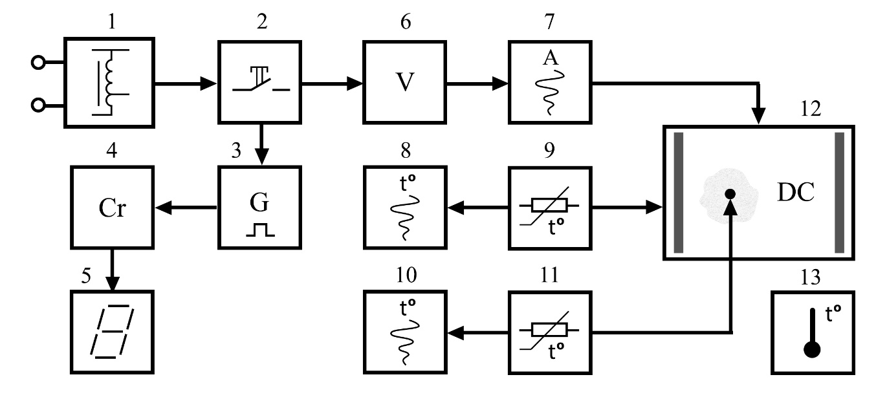

***Figure 2 – Functional Diagram of the Experimental Setup***

The key component of the setup is a rectangular dielectric chamber (DC) 12, made of polymethyl methacrylate (plexiglass) with a wall thickness of 5 mm and a side size of 0.02x0.12x0.23 m. Two 2mm-thick fixed steel electrodes 0.02x0.14 m in size are placed on the narrow opposite side walls inside the chamber having special connectors in the upper part for connecting power cables. The configuration of the chamber is selected in such a way as to provide the largest contact area with the environment with a sufficiently small volume of the feed mixture.

The installation is powered from a 220 V AC mains supplied to the input of laboratory autotransformer 1, at the output of which a serially connected push-button switch 2 with position fixation is installed to close the circuit. The values of the supplied voltage from the output of the autotransformer are determined by the readings of voltmeter 6, and ammeter 7 connected to the logger records the current consumed by the unit during operation [2].

To control the temperature of the outer surface of the dielectric chamber and the temperature of the feed mixture, two calibrated temperature sensors 9 and 11 based on chromel-copel thermocouples are used, connected to thermometers 8 and 10, which have the data recording feature. Digital thermometer 13 is used to determine the ambient temperature.

The duration of feed mixture heating, as well as the time to maintain the required temperature for the second stage of the experiment, are controlled by a digital stopwatch, which consists of a generator of second pulses 3 started when the switch button 2 is pressed, a pulse counter 4 and a display unit 5, necessary to display the current operating time of the unit (in seconds).

A calibrated thermal imager was used in the experiment for additional visual control of the dynamics of thermal processes, as well as determination of possible areas of inhomogeneous heating of the DC surface.

**Experiment Conditions**

The feed mixture, the basis of which is a complete loose compound feed used for fattening pigs, with a water mass fraction of 60% and a temperature equal to the ambient temperature of 23 °C, is loaded into the interelectrode space of the unit chamber. To prevent the feed mixture from going beyond the boundaries of the DC during heating, the volume of which can significantly increase as a result of moisture absorption by the feed components, as well as the thermal expansion of the liquid itself, an incomplete filling is provided with a volume of 4.6·10-4 m3 (equivalent weight - 0,41 kg).

Thermocouple 11 is placed in the inner cavity of the chamber to a depth equal to half the height of the DC, and at an equal distance between the nearest walls of the chamber. Electronic thermometer 13 is installed next to the DC of the experimental setup at a distance of up to 0.3 m.

In order to exclude the intensification of heat exchange due to the movement of air flows and, consequently, increased heat losses into the environment, the experiment was carried out in an isolated room with a uniformly distributed temperature throughout the volume.

By adjusting autotransformer 1, the supply voltage of the unit was selected based on the process conditions and amounted to 150 V for the given chamber configuration [2].

Temperature control in a steady-state mode was carried out by changing the supply voltage during the time required for complete heating of the chamber wall and reaching the steady state temperature. At this stage of the experiment, temperature control was carried out according to the readings of digital thermometer 8.

**Experiment Results Analysis**

According to the above procedure for determining heat losses, the experiment included two stages:

- measurement of the parameters of the installation in a non-stationary mode, when the temperature inside the DC grew continuously throughout the experiment;

- measurement of the parameters while maintaining the required temperature of the feedstuff (steady state mode).

For the transient mode, heat transfer through the wall can be determined based on the graphs of changes in the temperature of the feed mixture *t*m and the temperature  of the outer wall of the DC (Figure 3).

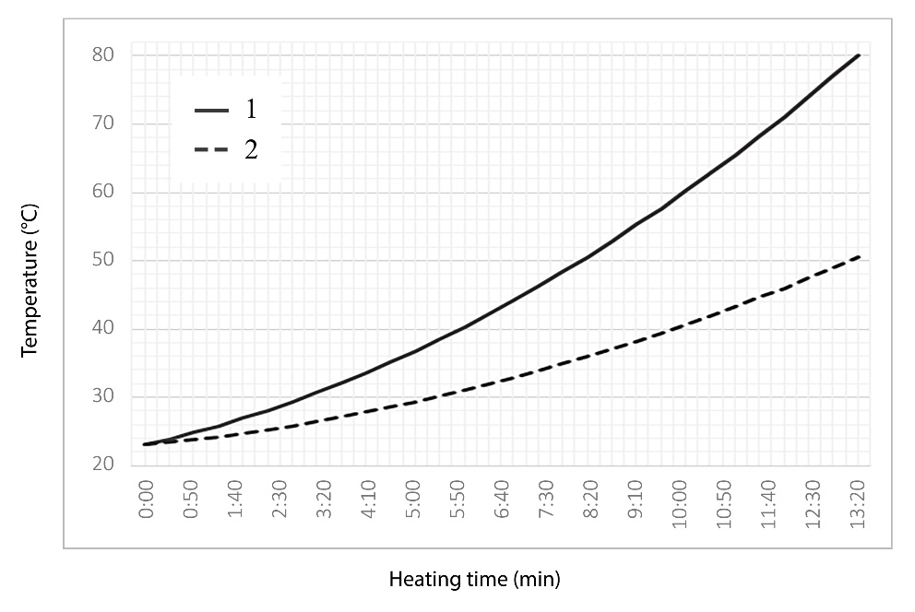

***Figure 3 – Temperature-heating time relation diagram: 1 – feed mixture temperature tm; 2 – temperature  of the outer wall of the DC***

The experiment has shown that as the temperature rises exponentially inside the chamber due to heating of the mixture (curve 1) the temperature head also increases (curves 1 and 2).

Due to the thermal inertia of the system resulting in rather a smooth change in the test sample temperature these temperature changes can be neglected for short time intervals, and the averaged values of temperatures for the current time interval can be used for calculations:

 (12)

where ******- time interval start and end points, respectively.

Then, approximate values of heat losses through the chamber walls can be obtained through applying the technique proposed for calculating the stationary flow for each sufficiently small time interval.

Figure 4 shows a graph of changes in the heat flux (curve 2), increased for clarity by 10 times. Curve 1, obtained experimentally, shows the amount of heat generation inside the entire volume.

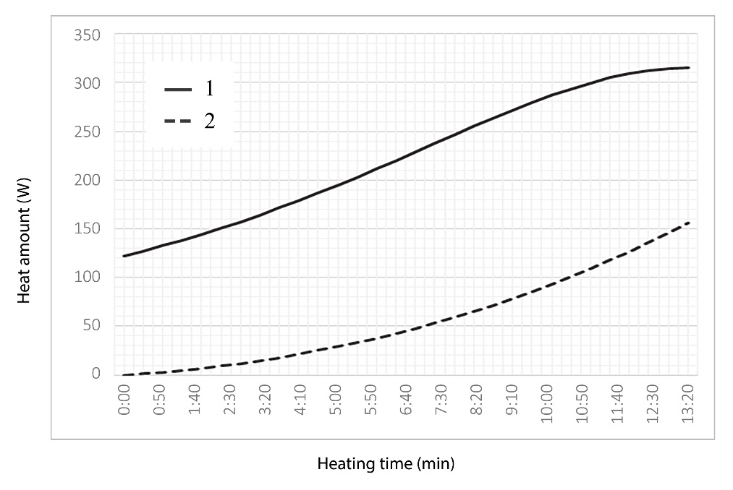

***Figure 4 – Heat flow-heating time ratio diagram: 1- heat generated in the mixture; 2 – heat losses 10⋅Ql through the outer walls of the DC***

Based on the data obtained (Table 1) the average heat loss during heating at any time has been found not to exceed 5% of the heat generated inside the feedstuff.

*Table 1- Calculated values of heat losses during feed mixture heating*

|  |  |  |  |  |  |  |  |  |  |  |
| --- | --- | --- | --- | --- | --- | --- | --- | --- | --- | --- |
| Heat generation Q, W | 102 | 106.5 | 109 | 114 | 118.5 | 124.5 | 129 | 133.5 | 138 | 141.8 |
| Heat losses Qi , W | 0.004 | 0.134 | 0.286 | 0.464 | 0.664 | 0.89 | 1.138 | 1.414 | 1.71 | 2.036 |
| (Qi /Q)100, % | 0.004 | 0.126 | 0.261 | 0.407 | 0.56 | 0.715 | 0.882 | 1.059 | 1.239 | 1.436 |
|  |  |  |  |  |  |  |  |  |  |  |
| Heat generation Q, W | 147 | 149.7 | 154.5 | 159 | 164.7 | 169.5 | 176.2 | 180 | 183.7 | 189.3 |
| Heat losses Qi , W | 2.388 | 2.766 | 3.17 | 3.6 | 4.064 | 4.552 | 5.072 | 5.622 | 6.206 | 6.82 |
| (Qi /Q)100, % | 1.624 | 1.848 | 2.052 | 2.264 | 2.467 | 2.685 | 2.878 | 3.123 | 3.377 | 3.603 |
|  |  |  |  |  |  |  |  |  |  |  |
| Heat generation Q, W | 193.5 | 196.8 | 202.5 | 206.2 | 210 | 211.8 | 213.7 | 216 | 217.5 | 218.7 |
| Heat losses Qi , W | 7.462 | 8.144 | 8.856 | 9.604 | 10.38 | 11.2 | 12.05 | 12.95 | 13.88 | 14.85 |
| (Qi /Q)100, % | 3.856 | 4.138 | 4.373 | 4.656 | 4.945 | 5.288 | 5.638 | 5.993 | 6.379 | 6.788 |

The higher percentage of heat loss observed at the end of the heating (starting from 10 minutes) to the temperature required for the process (Figure 4, curve 1) is explained by the significant thermal inertia of the system: the feed mixture and the chamber wall in question, which, continues to warm up for some time (curve 2) after a decrease in the level of heat generation in the volume.

At the stage of the regulation process, with a steady state *t*m=const, no significant change in the value of heat transfer from a heated wall with a temperature of 50.4 ˚C to an environment with a temperature of 23 ˚C was observed remaining at 14.86 ± 0.02 W, which indicates insignificant heat loss even for such a DC configuration.

Below are the thermal images of the experimental setup (Figure 5a) obtained in a steady state mode, as well as an image of the most preferable disinfection chamber (Figure 5b).

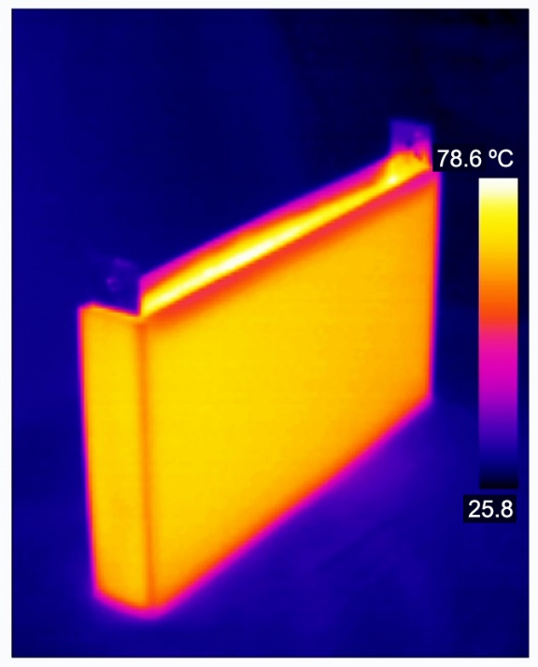 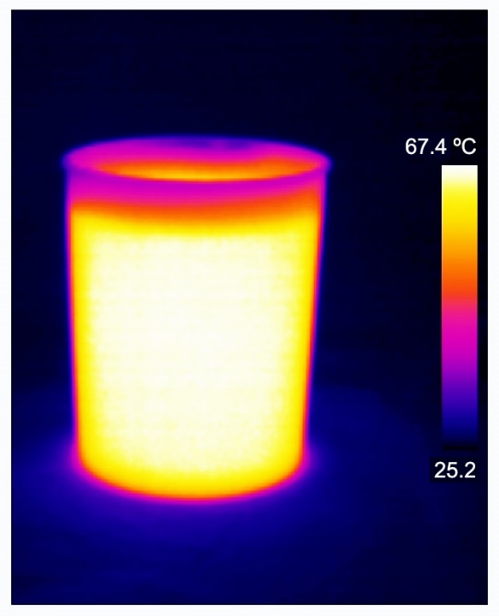

а) b)

***Figure 5– Thermal images: а) – rectangular experimental setup; b) – cylindrical container with the heated feed mixture***

Figure 6 shows a thermal image with the distribution of the temperature field through the chamber wall.

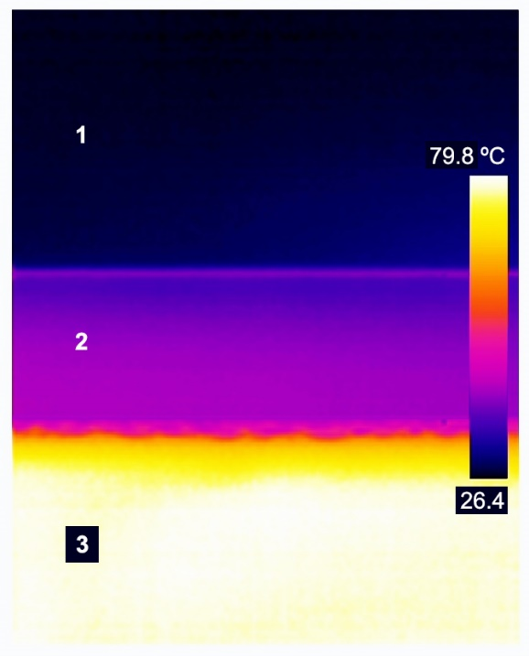

***Figure 6 – Thermal image of temperature distribution through the partition wall: 1 – environment (air); 2 – dielectric chamber wall; 3 – heated feed mixture***

The studies carried out have shown that with a decrease in the surface area of the enclosing walls of the DC unit, the heat loss due to heat transfer turns out to be negligible. At the same time, ensuring the lowest heat losses without the use of additional heat-insulating materials enclosing the unit is possible when using DC of cylindrical shapes.

**Conclusion**

1. The analysis of the mechanism of the appearance of the temperature gradient was carried out, as a result of which it was found that the temperature field is uniform throughout the entire volume of the feed mixture, an exponential decrease in temperature is observed only in the regions adjacent to the walls of the dielectric chamber, cooled from outside by air.

2. A diagram was provided for the experimental setup with a description of the physical parameters of the heating chamber at a supply voltage of 150 V.

3. Experimentally, the relation between the temperatures and the heating time was established for points inside the volume of the feed mixture and on the outer wall in a transient mode of heat exchange, the values of the temperature head were determined.

4. Based on the equations of thermal conductivity, the heat transfer coefficients were calculated for the areas of contact between the media (feed mixture - environment), and the values of temperatures at these boundaries were determined.

5. The dependence of the growth of heat losses for a non-stationary mode of heat exchange in the process of heating the feed mixture is established, the values of which do not exceed 4% of the energy spent on heating the mixture.

6. The presented thermal images show the distribution of the heat flow for different configurations of dielectric chambers of the EC unit: cylindrical and rectangular parallelepiped.

**References**

[1] Gorshkov A V and Prosviryakov E Y 2020 Nonstationary laminar Bénard-Marangoni convection for Newton-Richmann heat exchange. In *AIP Conference Proceedings* (Vol. 2315, No. 1, p. 050010). AIP Publishing LLC.

[2] Dorozhkin M.V., Khalina, T. M., Khalin, M. V., Analysis of the skin effect impact in the technology of disinfection of fodder mixtures by electric contact heating. International Journal on Technical and Physical Problems of Engineering (IJTPE), Issue 38, pp. 170-174, October 2020.

[3] Anne Huss, Roger Cochrane, Cassie Jones, Griffiths G. Atungulu, Physical and Chemical Methods for the Reduction of Biological Hazards in Animal Feeds, Food and Feed Safety Systems and Analysis, 10.1016/B978-0-12-811835-1.00005-1, pp. 83-95, 2018.

[4] F.T. Jones, K.E. Richardson. Salmonella in commercially manufactured feeds. Poult. Sci., 83 (2004), pp. 384-391

[5] Montecucco A, Buckle JR, Knox A R. Solution to the 1-D unsteady heat conduction equation with internal Joule heat generation for thermoelectric devices. Appl Therm. Eng. 2012;35(1):177–84.

[6] Qin Y, Brockett A, Ma Y, Razali A, Zhao J, Harrison C, Pan W, Dai X, Loziak D (2010) Micro-manufacturing: research, technology outcomes, and development issues. Int J Adv Manuf Technol 47:821–837. doi:10.1007/s00170-009-2411-2

[7] S. Dilmac, A. Guner, F. Senkal, S. Kartal, Simple method for calculation of heat loss through floor/beam-wall intersections according to ISO 9164, Energy Conversion and Management, Vol. 48, Issue 3, (2007), pp. 826-835

[8] Mamun A. A., Chowdhury Z. R., Azim M. A., and Maleque M. A., Conjugate Heat Transfer for a Vertical Flat Plate with Heat Generation Effect, *NAMC*, vol. 13, no. 2, pp. 213-223, Apr. 2008.

[9] M. Miyamoto, J. Sumikawa, T. Akiyoshi, T. Nakamura, Effects of axial heat conduction in a vertical flat plate on free convection heat transfer, International Journal of Heat and Mass Transfer, 23, pp. 1545–1553, 1980

[10] Kundu, Balaram, and Kwan-Soo Lee., Exact analysis for minimum shape of porous fins under convection and radiation heat exchange with surrounding. *International Journal of Heat and Mass Transfer* 81 (2015): 439-448.

[11] De Lima, J. A. S., and J. Santos., Generalized Stefan-Boltzmann law. *International Journal of Theoretical Physics* 34.1 (1995): 127-134.